# Index

**Introduction To The Project**

**Objective**

**System Analysis**

**Feasibility Study**

**Requirements**

**System Design**

**Database**

**Coding**

**Screen Shots**

**Testing**

**Conclusion**

**Limitation**

**Future Scope**

**References**

## INTRODUCTION

### Introduction

Online Cab Booking System specializing in Hiring cabs to customers. It is an online system through which customers can view available cabs; register the cabs, view profile and book cabs.. Cab booking service is a major transport service provided by the various transport operators in a particular city. Mostly peoples use cab service for their daily transportations need. The company must be a registered and fulfils all the requirements and security standards set by the transport department.

Online Cab Booking System is a web based platform that allows your customers to book their taxi's and executive taxis all online from the comfort of their own home or office. The platform should offer an administration interface where the taxi company can manage the content, and access all bookings and customer information. More and more Taxi companies are looking for integrated taxi booking systems as it makes life much easier for (1) The traveler - this is highly important and in today's internet age people should be able to book taxis online without having to pick up the phone and (2) the taxi company as all their bookings are now managed via an automated system which means they have an electronic record of future and historic bookings

A Cab Booking/Hiring is a system that can be used temporarily for a period of time with a fee. Hiring a car assists people to get around even when they do not have access to their own personal vehicle or don't own a vehicle at all. The individual who want to hire/rent a car must first contact the cab hiring company for the desire vehicle. This can be done online. At this point, this person has to supply some information such as: dates of rental, and type of car. After these details are worked out, the individual renting the car must present a valid Identification Card. Most companies throughout the industry make a profit based of the type of cars. The hiring cabs are categorized into economy, compact, compact

premium; premium and luxury & customers are free to choose any car of their choice based on their purse and availability of such car at the time of reservation.

Chandigarh Cab Service is the first site in India, which provides reliable online (web based) cab booking facility to the people in various cities of India., free of cost. Trinity Cab Service acts like a bridge between the cab operators & the customers/ users/ people who book a cab. This is the online cab booking service provided to customers. This bridges together the registration travel agencies/ cab operator/ cab owners & the customers.

[www.chandigarhcabservice.com](http://www.chandigarhcabservice.com/) provides this service i.e. we provide free registration for the cab owners & free service to travels/ customers/ users who go for booking a cab or taxi. Here the traveler can book a cab/ taxi/ car by viewing all the cab details and pricing details available, according to selected city and area. It is the reliable service provided to both customers and travel agencies. This provides service with well-conditioned new vehicles, with experience drivers for a happy journey of the customers. This project intends to introduce more user friendly in the various activities such as record updating, maintenance, and searching. This service is provided by the young entrepreneur who is living in the Chandigarh. He is feeling something is missing in city to overcome people day to day problems. The following Online Cab Booking having the following services: -

1. **Enhance Business Processes:** To be able to use internet technology to project the rental company to the global world instead of limiting their services to their local domain alone, thus increase their Return on Investment (ROI).
2. **Traveler’s registration:** A registration portal to hold traveler’s details, monitor their transaction and used same to offer better and improve services to them.
3. **Group bookings:** Allows the customer to book space for a group in the case of weeding or corporate parties or meetings.
4. **Eco-friendly:** The monitoring of the vehicle activity and the overall business becomes easy and includes the least of paper work.
5. **Availability:** The software acts as an office that is open 24/7.
6. **Efficient:** It increases the efficiency of the management at offering quality services to the customers.
7. **User friendly:** It provides custom features development and support with the software’s.
8. **Security:** The subsystem should provide a high level of security and integrity of the data held by the system, only authorized personnel of the company can gain access to the company’s secured page on the system; and only users with valid password and username can login to view user’s page.

#### Following are the Processes-

1. **Cab Search-**

Users can search cab for a particular location here. Users required to enter source, Destination, & place where he wants to go.

#### Login Search-

In the customers has to give out the login details i.e. user’s id and password and then only he can be logged on. The user id and password given by the customers are checked from the data stored in the database.

#### Registration Process-

User must be registered before booking a cab. Proper validations will be provided to keep only authenticated users i.e. those users who will provide correct information. All the data supply by the user will be stored in database and it will be used for further validations and authenticated. During registration, users have to give login and password of their choice. Login names and password will be stored in the databases so that the users can directly login without registration again and again

### Problem Statement

### Problem Statement

The old manual system was suffering from a series of drawbacks. Since whole of the system was to be maintained with hands the process of keeping, maintaining and retrieving the information was very tedious and lengthy. The records were never used to be in a systematic order. there used to be lots of difficulties in associating any particular transaction with a particular context. If any information was to be found it was required to go through the different registers, documents there would never exist anything like report generation. There would always be unnecessary consumption of time while entering records and retrieving records. One more problem was that it was very difficult to find errors while entering the records. Once the records were entered it was very difficult to update these records.

### Objectives

### Objectives

* To keep the information of Customer.
* To keep the information of number of bookings in current month.
* To keep the detail of taxis route.
* To keep the information of cancellation and modification of booking in current month.
* To maintain the record of every employee of every route.

A computer based management system is designed to handle the entire primary Information required to manage the whole data. Separate database is maintained to handle all the details required for the correct statement calculation and generations. This project intends to introduce more user friendly in the various activities such as record updating, maintenance, and searching. The objective and scope of my project Online Cab Hiring System is to record the details various activities of user. It will simplify the task and reduce the paper work. To produce a web-based system that allow customer to register and reserve cab online During implementation every user will be given appropriate training to suit their specific needs. Specific support will also be provided at key points within the academic calendar. Training will be provided on a timely basis, and you will be trained as the new is Cab Hiring System rolled out to your area of responsibility.

To produce a web-based system that allow customer to register and reserve cab online and for the company to effectively manage their Cab hiring business. To ease customer’s task whenever they need to rent a cab or hire a cab.

## ANALYSIS OF THE PROJECT

## ANALYSIS OF THE PROJECT

### Project Overview:

We aim to become a pioneer in the vehicle rental industry by completely focusing on customers, our employees, growth, innovation and efficiency. All of these elements will drive us towards success and show us as one company that can perform and give value for money.

### Product Description

When it comes to cab rental services, Cool Service is the most trusted and reliable name in the travel business. The most advanced travel agents offering cab rental and car hire in India, making full use of information technology to improve the level of our efficiency. However, this is only one aspect of services. And this project continually strives to offer the best of services - both in terms of man and machine, to our clients Moreover, this project has a fleet of cars ranging from luxury to budget cabs. While, it offers online cab hire service for corporate houses. And this project claims to offer the best of rates, which are tailor-made depending upon the facilities, availed and offer both intercity and intra-city cab facilities. All cabs have proper permits and documentation so that the clients couldn't be hassled for the lack of documents. However, this project has strategic backup system for any eventuality. Cab drivers are educated, polite, and reliable and are trained to handle acute breakdowns. The cab service includes all categories of cars from luxury to budget.

Further, this project’s utmost priority is quality. To achieve this, vehicles are well maintained and tested for delivering optimum and uninterrupted performance. Team of professionals in the travel business enables this system to design trips that suits to all budgets and preferences of the travelers. In addition, workforce including drivers and administrative

### Project Plan

It was decided to use good Software engineering principals in the development of the system since the server in the network always is running state for the user requests.

1. The Analysts will interact with the current manual system users to get the Requirements. As a part of this the Requirements Specification Document will be created.
2. The requirements Specifications document will contain the Analysis & Design of the system.
3. The Analysis, Design, Implementation & testing of the System will be followed to produce an incremental cycle, which will deliver milestones like the Requirements Specification Document etc., at the end of each of the iterations, Phases or cycles.
4. The Architecture & Technologies will be decided as a part of the Analysis of the requirements.
5. Once the Design is ready the Implementation & Testing strategy of the system will commence. Each will be independent of the other. The implementation of the system itself will be broken down into sub-systems following the Software Engineering principles for the development of robust software.
6. Once the implementation is ready, the System testing will take place. If the system is judged to be stable, then Acceptance testing by the Users will take place & once the Users are satisfied the System will be rolled out to the Users & they will be trained on how to use it for an initial period.

The following chapters contain an account of how the Technology & architecture for the system were chosen.

### System Analysis

### System Analysis

### Existing System:

Cool cab Service is an innovative thought to simplify the Transportation problems of Employees of an organization. In the present System, Organization do maintain a person for the allocating and proper functioning of transportation. The Person appointed needs to look after the assigning and movement of cabs.Authorized person maintains the

transportation details in papers, which is a tedious task if any updations or changes need to be done.

* Details are stored in Papers.
* Maintenance is a huge problem.
* Updation, changes in details is a tedious task.
* Performance is not achieved up to the requirements.

### Proposed System

In the Previous System, Details are Stored Manually in papers, to share the details between employees was a Financial drawback. Updations in the details is a tedious task.But a new system was proposed to overcome the above drawbacks.

Functionalities and advantages of proposed system are:

* + - * Data is Centralized which has overcome the Sharing problem in previous system.
      * As data is Maintained electronically, it’s easy for a person to update the details, which has overcome the tedious updation in previous system.
      * Maintenance is easy and performance is good.
      * Mainly the system has automated the Transportation Process.

### Use Case Template

**Source / Destination**: - Use case specification

**Brief Description: -** The main use of this use caseis to provide the details about source and the destination of the user of the cab.

#### Flow of Events: -

**Basic Flow**: -

1. User books a cab by providing the details of source and destination.
2. Booking clerk check the database.
3. On successful traveler makes the booking of the cab.

#### Pre conditions:

The traveler should have a cab for a destination place.

#### Post conditions:

The database must be modified after the booking transaction takes place.

#### 2. Date / Time:

Use case specification

#### Brief Description:

The main purpose of this use case is to know details about the number of cabs available at that particular date.

### MODULE

This project contains 2 main modules

* Customer Module
* Driver Module

I am working on Customer Module right now.

#### The project consists of four main views:

* **Log in:** A Login screen with user and password text fields. There’s a “Sign Up” button to go to the Sign Up view to create a new user.
* **Sign Up:** In this view, the user introduces the username and password to create a new account with the backend service.
* **Wall:** This is the main screen of the app. Here the user can see all of the other users uploaded images, the creation date and the comment associated with them.
* **Map:** In this view user can see the nearest cab and its location and timing and also their movement and rout.

Each view has its own **UI ViewController** in the storyboard.

**Fessibility Study**

**Feasibility Study**

Preliminary investigation examine project feasibility, the likelihood the system will be useful to the organization. The main objective of the feasibility study is to test the Technical, Operational and Economical feasibility for adding new modules and debugging old running system. All system is feasible if they are unlimited resources and infinite time. There are aspects in the feasibility study portion of the preliminary investigation:

¬ Technical Feasibility

¬ Operation Feasibility

¬ Economical Feasibility

**Technical Feasibility**

The technical issue usually raised during the feasibility stage of the investigation includes the following:

¬ Do the proposed equipments have the technical capacity to hold the data required to use the new system?

¬ Will the proposed system provide adequate response to inquiries, regardless of the number or location of users?

¬ Are there technical guarantees of accuracy, reliability, ease of access and data security?

**Operational Feasibility**

Proposed projects are beneficial only if they can be turned out into information system. That will meet the organization’s operating requirements. Operational feasibility aspects of the project are to be taken as an important part of the project implementation. Some of the important issues raised are to test the operational feasibility of a project includes the following: -

¬ Is there sufficient support for the management from the users?

¬ Will the system be used and work properly if it is being developed and implemented?

¬ Will there be any resistance from the user that will undermine the possible application benefits?

**Economical Feasibility**

A system can be developed technically and that will be used if installed must still be a good investment for the organization. In the economical feasibility, the development cost in creating the system is evaluated against the ultimate benefit derived from the new systems. Financial benefits must equal or exceed the costs.

**Legal Feasibility**

In the legal feasibility it is necessary to check that the software we are going to develop is legally correct which means that the ideas which we have taken for the proposed system will be legally implemented or not so,it is also an important step in feasibility study.

**Hardware & Software Requirement**

**Hardware configuration**

* Processor                    core i3 or above
* RAM                          4 GB Ram
* Monitor                      15 inch color
* Hard disk                    1 TB
* Floppy drive               1.44 MB
* CD drive                     LG 52X
* Key board                   Standard US Keyboard
* Mouse

**Software configuration**

* Operating system       Windows 7 or above
* Language                   C++ - Language

**C++ Language Introduction**

**Introduction**

C++ is a general-purpose programming language that was developed as an enhancement of the C language to include object-oriented paradigm. It is an imperative and a compiled language. 

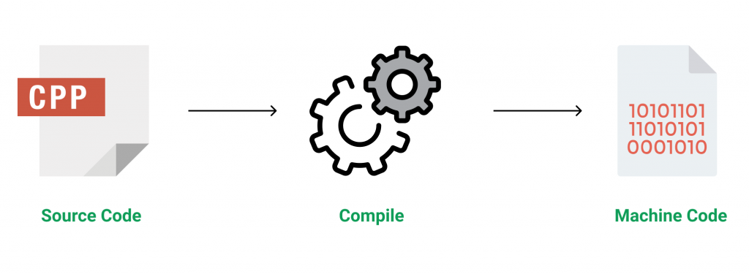

C++ is a middle-level language rendering it the advantage of programming low-level (drivers, kernels) and even higher-level applications (games, GUI, desktop apps etc.). The basic syntax and code structure of both C and C++ are the same.

**Some of the features & key-points to note about the programming language are as follows:**

* Simple: It is a simple language in the sense that programs can be broken down into logical units and parts, has a rich library support and a variety of data-types.
* Machine Independent but Platform Dependent: A C++ executable is not platform-independent (compiled programs on Linux won’t run on Windows), however they are machine independent.
* Mid-level language: It is a mid-level language as we can do both systems-programming (drivers, kernels, networking etc.) and build large-scale user applications (Media Players, Photoshop, Game Engines etc.)
* Rich library support: Has a rich library support (Both standard ~ built-in data structures, algorithms etc.) as well 3rd party libraries (e.g. Boost libraries) for fast and rapid development.
* Speed of execution: C++ programs excel in execution speed. Since, it is a compiled language, and also hugely procedural. Newer languages have extra in-built default features such as garbage-collection, dynamic typing etc. which slow the execution of the program overall. Since there is no additional processing overhead like this in C++, it is blazing fast.
* Pointer and direct Memory-Access: C++ provides pointer support which aids users to directly manipulate storage address. This helps in doing low-level programming (where one might need to have explicit control on the storage of variables).
* Object-Oriented: One of the strongest points of the language which sets it apart from C. Object-Oriented support helps C++ to make maintainable and extensible programs. i.e. Large-scale applications can be built. Procedural code becomes difficult to maintain as code-size grows.
* Compiled Language: C++ is a compiled language, contributing to its speed.

**Applications of C++:**

* C++ finds varied usage in applications such as:
* Operating Systems & Systems Programming. e.g. Linux-based OS (Ubuntu etc.)
* Browsers (Chrome & Firefox)
* Graphics & Game engines (Photoshop, Blender, Unreal-Engine)
* Database Engines (MySQL, MongoDB, Redis etc.)
* Cloud/Distributed Systems

[**Some interesting facts about C++**](https://www.geeksforgeeks.org/interesting-facts-about-c/)**:**

Here are some awesome facts about C++ that may interest you:

* The name of C++ signifies the evolutionary nature of the changes from C. “++” is the C increment operator.
* C++ is one of the predominant languages for the development of all kind of technical and commercial software.
* C++ introduces Object-Oriented Programming, not present in C. Like other things, C++ supports the four primary features of OOP: encapsulation, polymorphism, abstraction, and inheritance.
* C++ got the OOP features from Simula67 Programming language.
* A function is a minimum requirement for a C++ program to run.(at least main() function)

## Why to Learn C++

**C++** is a MUST for students and working professionals to become a great Software Engineer. I will list down some of the key advantages of learning C++:

* C++ is very close to hardware, so you get a chance to work at a low level which gives you lot of control in terms of memory management, better performance and finally a robust software development.
* **C++ programming** gives you a clear understanding about Object Oriented Programming. You will understand low level implementation of polymorphism when you will implement virtual tables and virtual table pointers, or dynamic type identification.
* C++ is one of the every green programming languages and loved by millions of software developers. If you are a great C++ programmer then you will never sit without work and more importantly you will get highly paid for your work.
* C++ is the most widely used programming languages in application and system programming. So you can choose your area of interest of software development.
* C++ really teaches you the difference between compiler, linker and loader, different data types, storage classes, variable types their scopes etc.

There are 1000s of good reasons to learn C++ Programming. But one thing for sure, to learn any programming language, not only C++, you just need to code, and code and finally code until you become expert.

# Structure of C++ Program

* Difficulty Level : [Basic](https://www.geeksforgeeks.org/basic/)
* Last Updated : 15 Dec, 2020

The [C++ program](https://www.geeksforgeeks.org/c-plus-plus/) is written using a specific [template structure](https://www.geeksforgeeks.org/templates-cpp/). The structure of the program written in C++ language is as follows:

[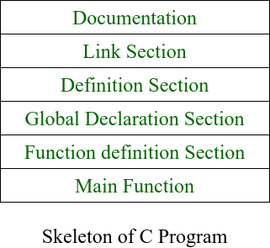](https://media.geeksforgeeks.org/wp-content/uploads/20201028224032/BasicStructureOfCProgram.png)

### **Documentation Section:**

* This section comes first and is used to document the logic of the program that the programmer going to code.
* It can be also used to write for purpose of the program.
* Whatever written in the documentation section is the comment and is not compiled by the compiler.

### **Linking Section:**

The linking section contains two parts:

**Header Files:**

* Generally, a program includes various programming elements like [built-in functions](https://www.geeksforgeeks.org/builtin-functions-gcc-compiler/), classes, keywords, [constants](https://www.geeksforgeeks.org/constants-in-c-cpp/), [operators](https://www.geeksforgeeks.org/interesting-facts-bitwise-operators-c/), etc. that are already defined in the standard [C++ library](https://www.geeksforgeeks.org/the-c-standard-template-library-stl/).
* In order to use such pre-defined elements in a program, an appropriate header must be included in the program.
* Standard headers are specified in a program through the [preprocessor directive #include](https://www.geeksforgeeks.org/cc-preprocessors/). In Figure, the iostream header is used. When the compiler processes the instruction #include<iostream>, it includes the contents of the stream in the program. This enables the programmer to use standard input, output, and error facilities that are provided only through the standard streams defined in <iostream>. These standard streams process data as a stream of characters, that is, data is read and displayed in a continuous flow. The standard streams defined in <iostream> are listed here.

*#include<iostream>*

**Namespaces:**

* A namespace permits grouping of various entities like classes, [objects](https://www.geeksforgeeks.org/c-classes-and-objects/), [functions](https://www.geeksforgeeks.org/functions-in-c/), and various [C++ tokens](https://www.geeksforgeeks.org/cc-tokens/), etc. under a single name.
* Any user can create separate namespaces of its own and can use them in any other program.
* In the below snippets, [**namespace std**](https://www.geeksforgeeks.org/using-namespace-std-considered-bad-practice/) contains declarations for [cout](https://www.geeksforgeeks.org/difference-between-cout-and-stdcout-in-c/), cin, [endl](https://www.geeksforgeeks.org/endl-vs-n-in-cpp/), etc. statements.

**using namespace std;**

* Namespaces can be accessed in multiple ways:
  + using namespace std;
  + using std :: cout;

### **Definition Section:**

* It is used to declare some constants and assign them some value.
* In this section, anyone can define your own [datatype](https://www.geeksforgeeks.org/c-data-types/) using [primitive data types](https://www.geeksforgeeks.org/data-types-in-c/).
* In  **#define** is a compiler directive which tells the compiler whenever the message is found replace it with “Factorial\n” .
* **typedef int K;** this statement telling the compiler that whenever you will encounter K replace it by int and as you have declared k as datatype you cannot use it as an [identifier](https://www.geeksforgeeks.org/difference-between-keyword-and-identifier/).

### **Global Declaration Section:**

* Here the variables and the class definitions which are going to be used in the program are declared to make them global.
* The scope of the variable declared in this section lasts until the entire program terminates.
* These variables are accessible within the user-defined functions also.

### **Function Declaration Section:**

* It contains all the functions which our main functions need.
* Usually, this section contains the User-defined functions.
* This part of the program can be written after the main function but for this, write the function prototype in this section for the function which for you are going to write code after the [main function](https://www.geeksforgeeks.org/executing-main-in-c-behind-the-scene/).

[**Main Function**](https://www.geeksforgeeks.org/write-running-c-code-without-main/)**:**

* The main function tells the compiler where to start the execution of the program. The execution of the program starts with the main function.
* All the statements that are to be executed are written in the main function.
* The compiler executes all the instructions which are written in the curly braces **{}** which encloses the body of the main function.
* Once all instructions from the [main function are executed](https://www.geeksforgeeks.org/functions-that-are-executed-before-and-after-main-in-c/) control comes out of the main function and the program terminates and no further execution occur.

## Hello World using C++

Just to give you a little excitement about **C++ programming**, I'm going to give you a small conventional C++ Hello World program, You can try it using Demo link

C++ is a super set of C programming with additional implementation of object-oriented concepts.

#include <iostream>

using namespace std;

// main() is where program execution begins.

int main() {

cout << "Hello World"; // prints Hello World

return 0;

}

**C++ Compilers**

When you write any program in C++ language then to run that program you need to compile that program using a C Compiler which converts your program into a language understandable by a computer. This is called machine language (ie. binary format). So before proceeding, make sure you have C Compiler available at your computer. It comes alongwith all flavors of Unix and Linux.

If you are working over Unix or Linux then you can type *gcc -v* or *cc -v* and check the result. You can ask your system administrator or you can take help from anyone to identify an available C Compiler at your computer.

If you don't have C compiler installed at your computer then you can use below given link to download a GNU C Compiler and use it.

**System Design**

**System Design**

**Data Flow Diagram**

**DFD** is the abbreviation for **Data Flow Diagram**. The flow of data of a system or a process is represented by DFD. It also gives insight into the inputs and outputs of each entity and the process itself. DFD does not have control flow and no loops or decision rules are present. Specific operations depending on the type of data can be explained by a flowchart. Data Flow Diagram can be represented in several ways. The DFD belongs to structured-analysis modeling tools. Data Flow diagrams are very popular because they help us to visualize the major steps and data involved in software-system processes.

#### Components ofDFD

The Data Flow Diagram has 4 components:

* **Process**  
  Input to output transformation in a system takes place because of process function. The symbols of a process are rectangular with rounded corners, oval, rectangle or a circle. The process is named a short sentence, in one word or a phrase to express its essence
* **Data Flow**  
  Data flow describes the information transferring between different parts of the systems. The arrow symbol is the symbol of data flow. A relatable name should be given to the flow to determine the information which is being moved. Data flow also represents material along with information that is being moved. Material shifts are modeled in systems that are not merely informative. A given flow should only transfer a single type of information. The direction of flow is represented by the arrow which can also be bi-directional.
* **Warehouse**  
  The data is stored in the warehouse for later use. Two horizontal lines represent the symbol of the store. The warehouse is simply not restricted to being a data file rather it can be anything like a folder with documents, an optical disc, a filing cabinet. The data warehouse can be viewed independent of its implementation. When the data flow from the warehouse it is considered as data reading and when data flows to the warehouse it is called data entry or data updation.
* **Terminator**  
  The Terminator is an external entity that stands outside of the system and communicates with the system. It can be, for example, organizations like banks, groups of people like customers or different departments of the same organization, which is not a part of the model system and is an external entity. Modeled systems also communicate with terminator.

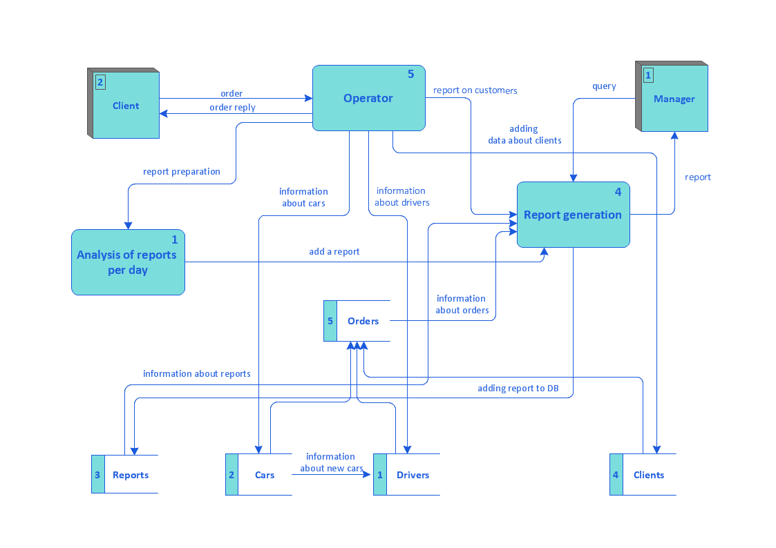

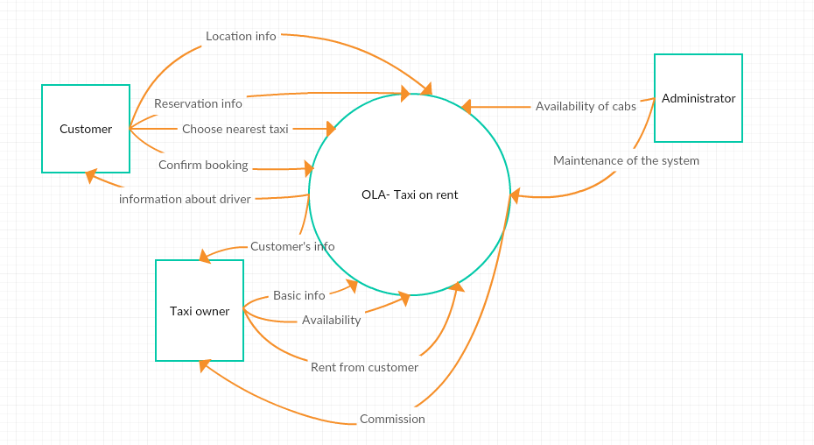

**ER Diagram**

**ER Diagram** stands for Entity Relationship Diagram, also known as ERD is a diagram that displays the relationship of entity sets stored in a database. In other words, ER diagrams help to explain the logical structure of databases. ER diagrams are created based on three basic concepts: entities, attributes and relationships.

ER Diagrams contain different symbols that use rectangles to represent entities, ovals to define attributes and diamond shapes to represent relationships.

At first look, an ER diagram looks very similar to the flowchart. However, ER Diagram includes many specialized symbols, and its meanings make this model unique. The purpose of ER Diagram is to represent the entity framework infrastructure.

**Entity, Entity Type, Entity Set –**

An Entity may be an object with a physical existence – a particular person, car, house, or employee – or it may be an object with a conceptual existence – a company, a job, or a university course.

An Entity is an object of Entity Type and set of all entities is called as entity set. e.g.; E1 is an entity having Entity Type Student and set of all students is called Entity Set. In ER diagram, Entity Type is represented as:

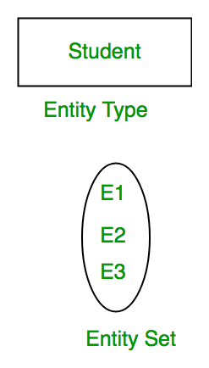

**Attribute(s):**   
Attributes are the **properties which define the entity type**. For example, Roll_No, Name, DOB, Age, Address, Mobile_No are the attributes which defines entity type Student. In ER diagram, attribute is represented by an oval.

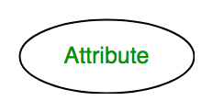

**1. Key Attribute –**   
The attribute which **uniquely identifies each entity** in the entity set is called key attribute.For example, Roll_No will be unique for each student. In ER diagram, key attribute is represented by an oval with underlying lines.

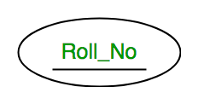

**2. Composite Attribute –**   
An attribute **composed of many other attribute** is called as composite attribute. For example, Address attribute of student Entity type consists of Street, City, State, and Country. In ER diagram, composite attribute is represented by an oval comprising of ovals.

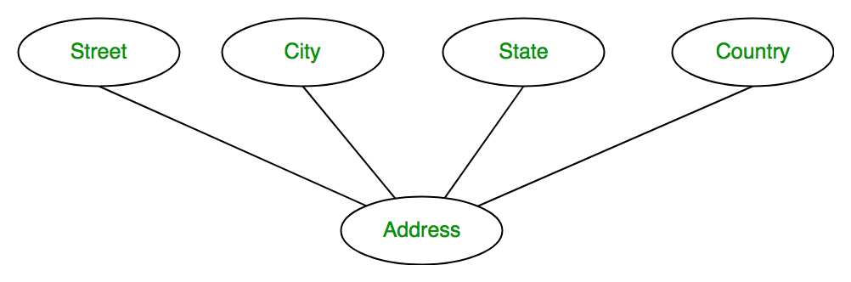

**3. Multivalued Attribute –**   
An attribute consisting **more than one value** for a given entity. For example, Phone_No (can be more than one for a given student). In ER diagram, multivalued attribute is represented by double oval.

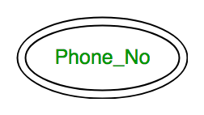

**4. Derived Attribute –**   
An attribute which can be **derived from other attributes** of the entity type is known as derived attribute. e.g.; Age (can be derived from DOB). In ER diagram, derived attribute is represented by dashed oval.

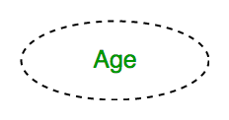

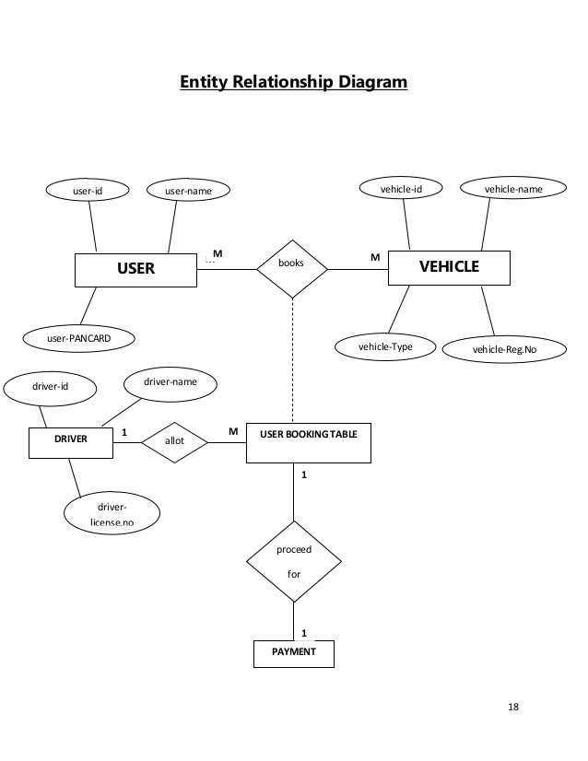

**Coding**

**Coding**

#include <iostream>

#include <fstream>

#include <conio.h>

#include <stdlib.h>

#include <unistd.h>

#include <dos.h>

#include <iomanip>

//Brought To You by code-projects.org

// included required library files

using namespace std;

class customer // customer class

{

private:

public:

string customername;

string carmodel;

string carnumber;

char data;

// variables defined in this class in public mode.

};

class rent : public customer // inhereted class from customer class

{

public:

int days=0,rentalfee=0; // additional int vatiables defined

void data()

{

int login();

login();

cout << "\t\t\t\tPlease Enter your Name: "; //taking data from the user

cin >> customername;

cout<<endl;

do

{

cout <<"\t\t\t\tPlease Select a Car"<<endl; //giving user a choice to select among three different models

cout<<"\t\t\t\tEnter 'A' for Tesla 20011."<<endl;

cout<<"\t\t\t\tEnter 'B' for Hyundai 2015."<<endl;

cout<<"\t\t\t\tEnter 'C' for Ford 2017."<<endl;

cout<<endl;

cout<<"\t\t\t\tChoose a Car from the above options: ";

cin >>carmodel;

cout<<endl;

cout<<"--------------------------------------------------------------------------"<<endl;

if(carmodel=="A")

{

system("CLS");

cout<<"You have choosed Tesla model 2011"<<endl;

ifstream inA("A.txt"); //displaying details of model A

char str[200];

while(inA) {

inA.getline(str, 200);

if(inA) cout << str << endl;

}

sleep(2);

}

if(carmodel=="B")

{

system("CLS");

cout<<"You have choosed Hyundai model 2015"<<endl;

ifstream inB("B.txt"); //displaying details of model B

char str[200];

while(inB) {

inB.getline(str, 200);

if(inB) cout << str << endl;

}

sleep(2);

}

if(carmodel=="C")

{

system("CLS");

cout<<"You have choosed Ford model 2017"<<endl;

ifstream inC("C.txt"); //displaying details of model C

char str[200];

while(inC) {

inC.getline(str, 200);

if(inC) cout << str << endl;

}

sleep(2);

}

if(carmodel !="A" && carmodel !="B" && carmodel !="C" )

cout<<"Invaild Car Model. Please try again!"<<endl;

}

while(carmodel !="A" && carmodel !="B" && carmodel !="C" );

cout<<"--------------------------------------------------------------------------"<<endl;

cout << "Please provide following information: "<<endl;

//getting data from user related to rental service

cout<<"Please select a Car No. : ";

cin >> carnumber;

cout<<"Number of days you wish to rent the car : ";

cin >> days;

cout<<endl;

}

void calculate()

{

sleep(1);

system ("CLS");

cout<<"Calculating rent. Please wait......"<<endl;

sleep(2);

if(carmodel == "A"||carmodel=="a")

rentalfee=days*56;

if(carmodel == "B" ||carmodel=="b")

rentalfee=days*60;

if(carmodel == "C" ||carmodel=="c")

rentalfee=days*75;

}

void showrent()

{

cout << "\n\t\t Car Rental - Customer Invoice "<<endl;

cout << "\t\t ///////////////////////////////////////////////////////////"<<endl;

cout << "\t\t | Invoice No. :"<<"------------------|"<<setw(10)<<"#Cnb81353"<<" |"<<endl;

cout << "\t\t | Customer Name:"<<"-----------------|"<<setw(10)<<customername<<" |"<<endl;

cout << "\t\t | Car Model :"<<"--------------------|"<<setw(10)<<carmodel<<" |"<<endl;

cout << "\t\t | Car No. :"<<"----------------------|"<<setw(10)<<carnumber<<" |"<<endl;

cout << "\t\t | Number of days :"<<"---------------|"<<setw(10)<<days<<" |"<<endl;

cout << "\t\t | Your Rental Amount is :"<<"--------|"<<setw(10)<<rentalfee<<" |"<<endl;

cout << "\t\t | Caution Money :"<<"----------------|"<<setw(10)<<"0"<<" |"<<endl;

cout << "\t\t | Advanced :"<<"---------------------|"<<setw(10)<<"0"<<" |"<<endl;

cout << "\t\t ________________________________________________________"<<endl;

cout <<"\n";

cout << "\t\t | Total Rental Amount is :"<<"-------|"<<setw(10)<<rentalfee<<" |"<<endl;

cout << "\t\t ________________________________________________________"<<endl;

cout << "\t\t # This is a computer generated invoce and it does not"<<endl;

cout << "\t\t require an authorised signture #"<<endl;

cout <<" "<<endl;

cout << "\t\t ///////////////////////////////////////////////////////////"<<endl;

cout << "\t\t You are advised to pay up the amount before due date."<<endl;

cout << "\t\t Otherwise penelty fee will be applied"<<endl;

cout << "\t\t ///////////////////////////////////////////////////////////"<<endl;

int f;

system("PAUSE");

system ("CLS");

ifstream inf("thanks.txt");

char str[300];

while(inf) {

inf.getline(str, 300);

if(inf) cout << str << endl;

}

inf.close();

}

};

class welcome //welcome class

{

public:

int welcum()

{

ifstream in("welcome.txt"); //displaying welcome ASCII image text on output screen fn1353

if(!in) {

cout << "Cannot open input file.\n";

}

char str[1000];

while(in) {

in.getline(str, 1000); // delim defaults to '\n' cp

if(in) cout << str << endl;

}

in.close();

sleep(1);

cout<<"\nStarting the program please wait....."<<endl;

sleep(1);

cout<<"\nloading up files....."<<endl;

sleep(1); //function which waits for (n) seconds

system ("CLS"); //cleares screen

}

};

int main()

{

welcome obj1; //object created for welcome class

obj1.welcum(); //welcum function is called

rent obj2;

//object created for rent class and further member functions are called

obj2.data();

obj2.calculate();

obj2.showrent();

return 0; //end of the program

}

int login(){

string pass ="";

char ch;

cout<<"\n\n\n\n\n\n\n\n\t\t\t\t\t CAB BOOKING SYSTEM \n\n";

cout<<"\t\t\t\t\t------------------------------";

cout<<"\n\t\t\t\t\t\t LOGIN \n";

cout<<"\t\t\t\t\t------------------------------\n\n";

cout << "\t\t\t\t\tEnter Password: ";

ch = _getch();

while(ch != 13){//character 13 is enter

pass.push_back(ch);

cout << '*';

ch = _getch();

}

if(pass == "pass"){

cout << "\n\n\n\t\t\t\t\t\tAccess Granted! \n";

system("PAUSE");

system ("CLS");

}else{

cout << "\n\n\t\t\t\t\t\t\tAccess Aborted...\n\t\t\t\t\t\t\tPlease Try Again\n\n";

system("PAUSE");

system("CLS");

login();

}

}

**Screenshot**

**SCREENS**

#### Launch Screen

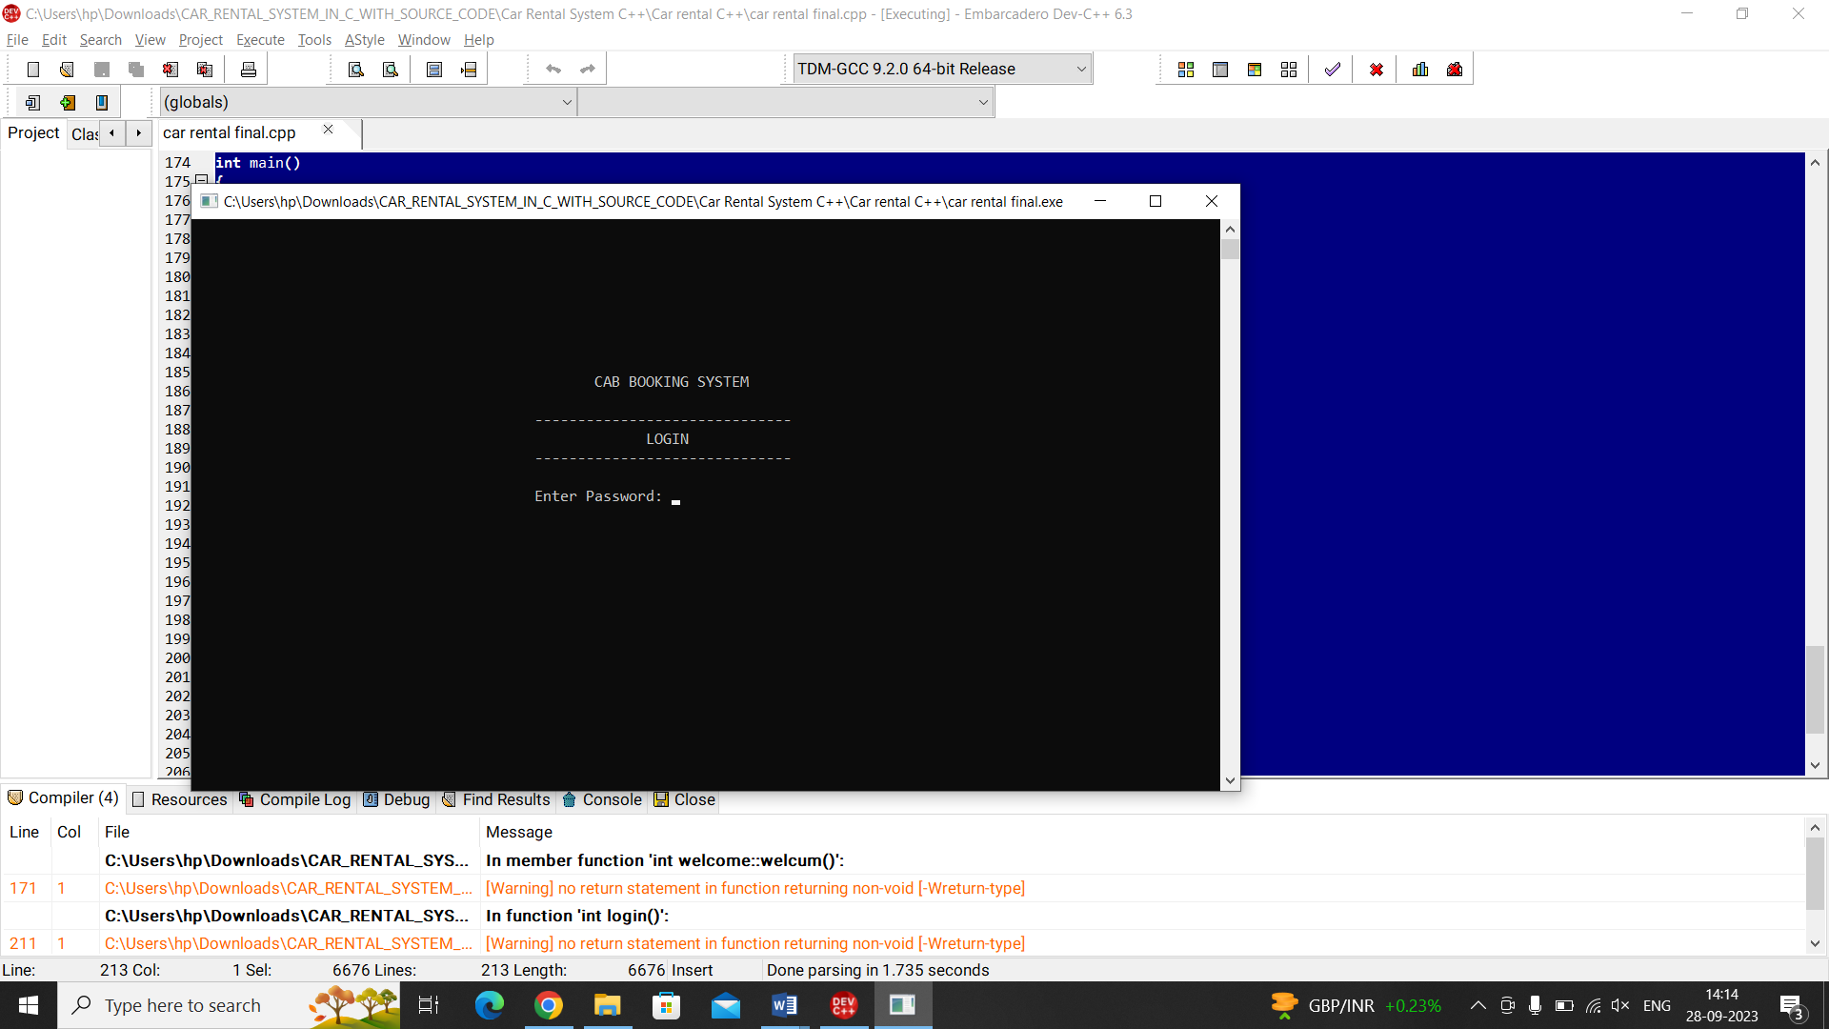

**Login Screen :**

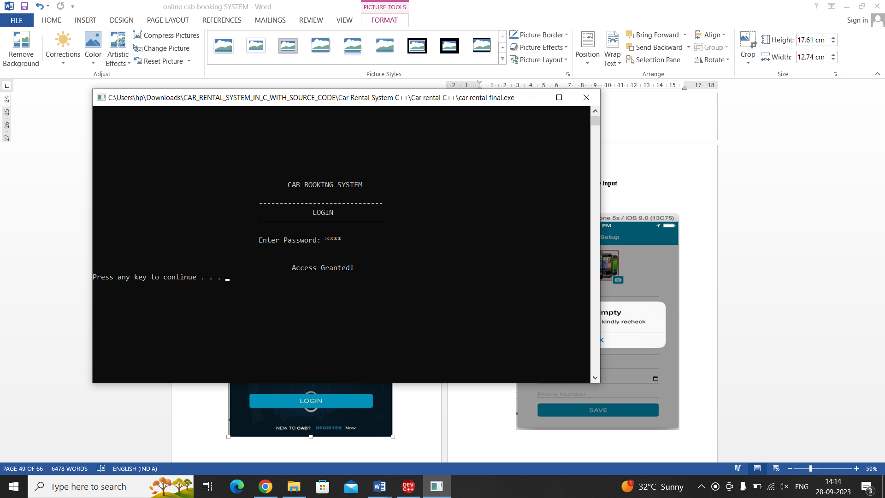

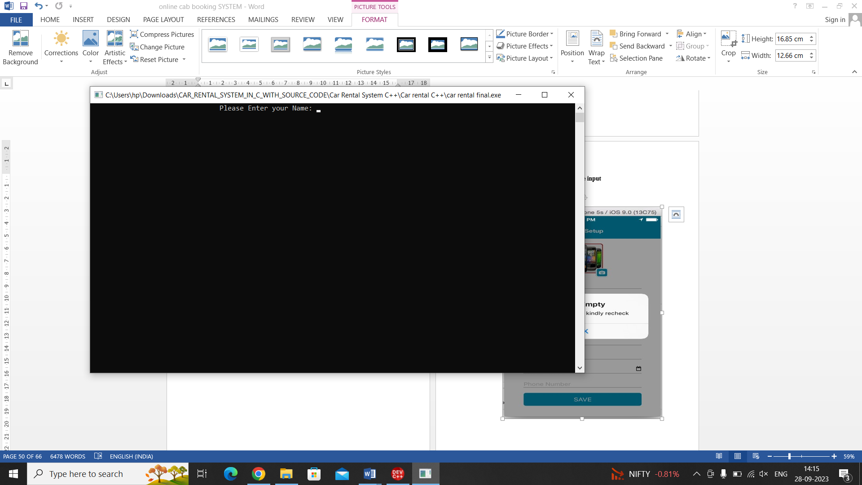**Enter Detail**

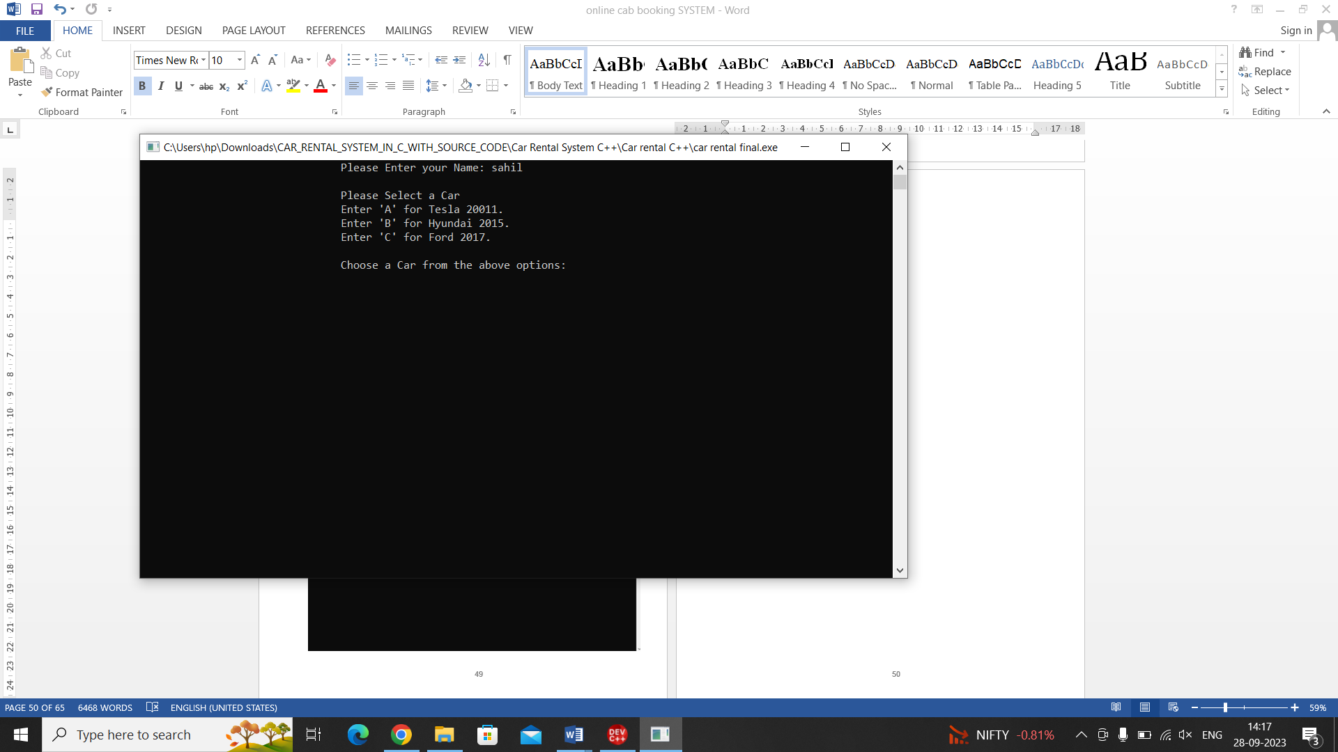

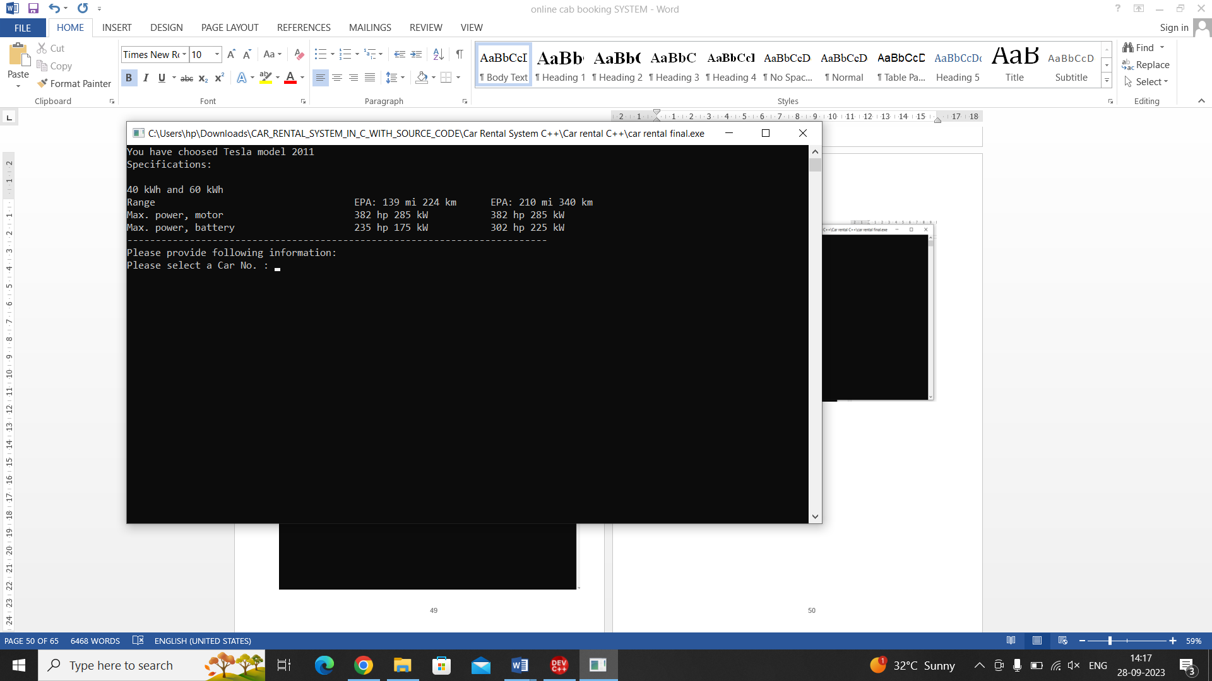

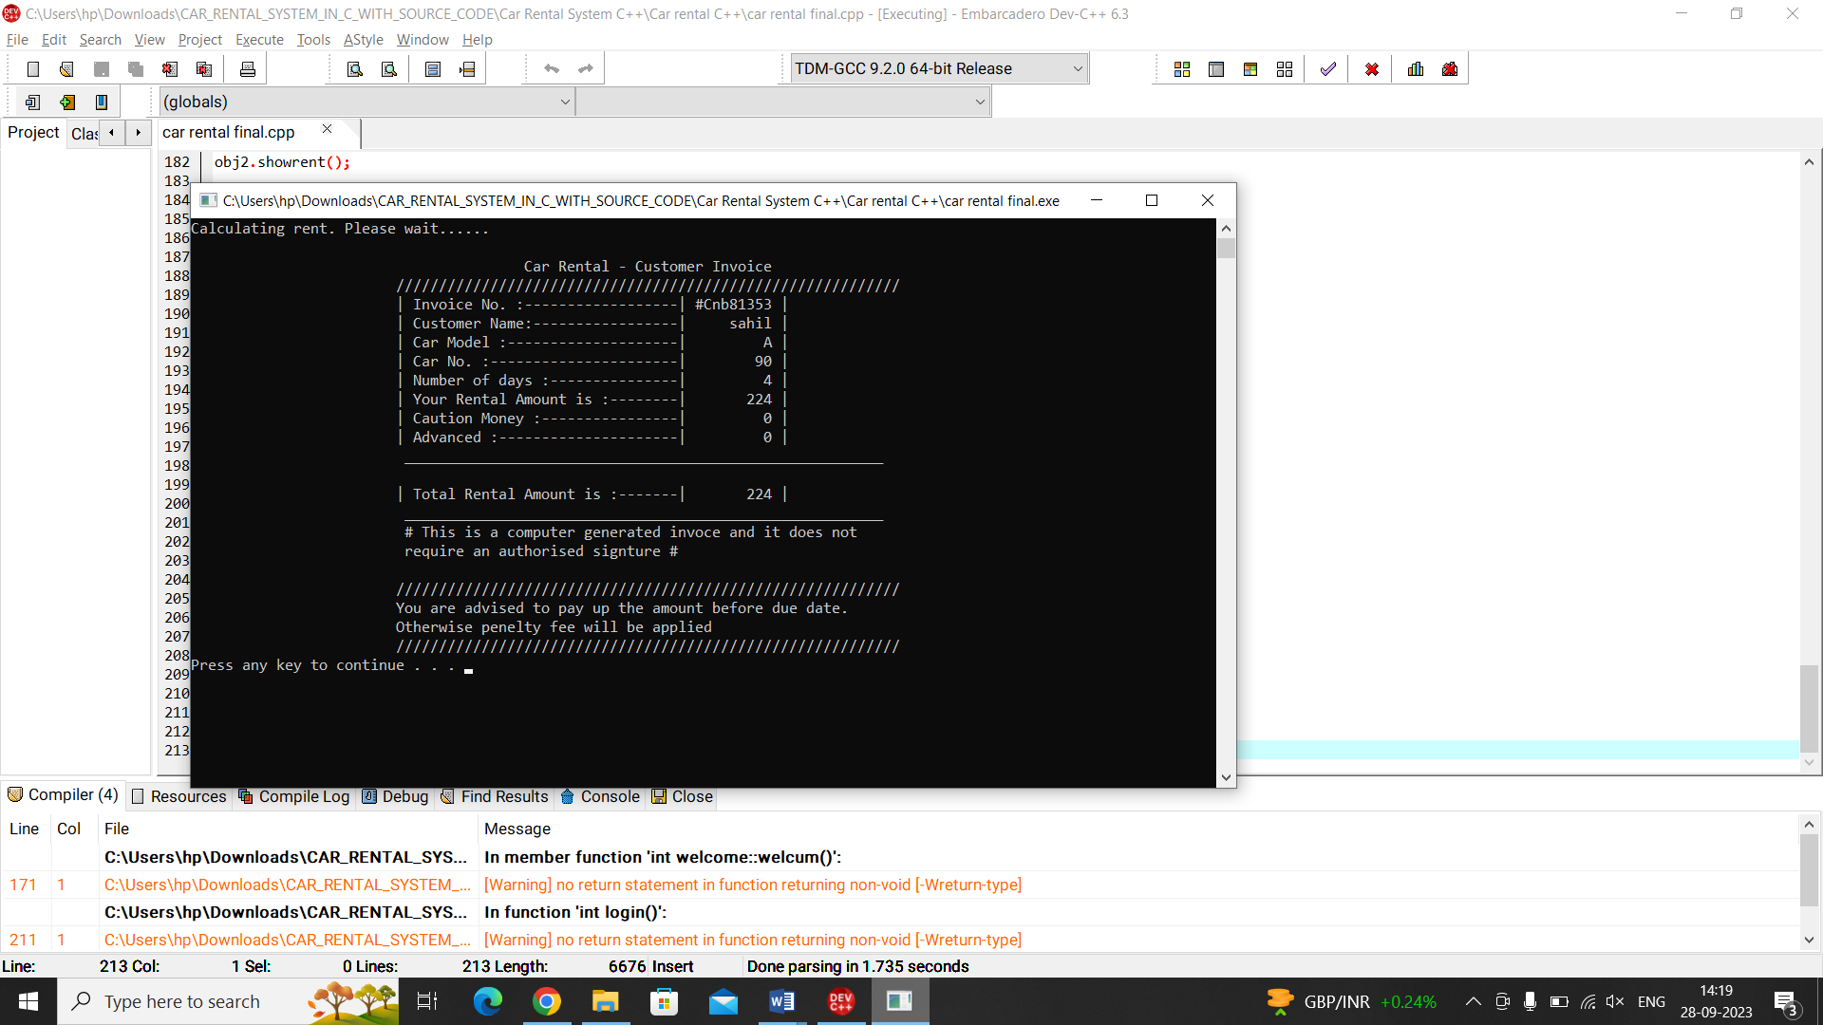

**Testing**

**Testing**

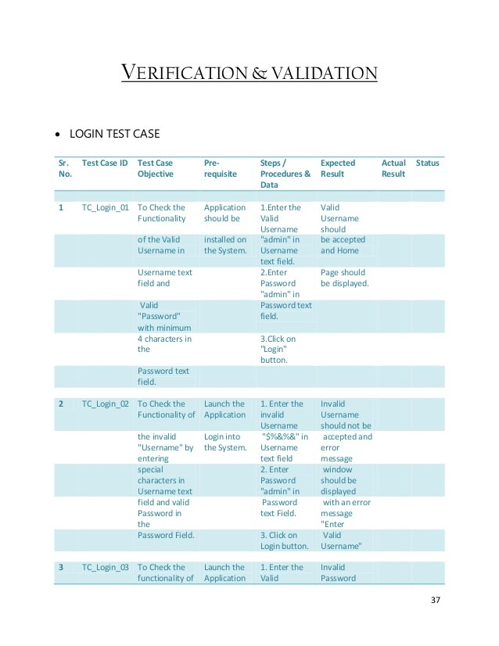

**Advantages**

**ADVANTAGES OF CAB BOOKING SYSTEM**

Now one can easily plan the journey comfortably as the process is efficient and fast with being easy to access. Bookings can be made through the cab booking site or by the phone call. This being a big step in terms of improvement in the cab system it is widely accepted across the country.A route-based booking system that facilitates the issue of journey-cum- booking cab, which can be issued from any station to any station.

Passenger journey to multiple laps of booking can be handled from a single terminal window.The booking facility is offered round-the-clock (24 hours uninterrupted).Changes in cab profiles (cab addition, replacement, de-allocation), route structures, etc., can be made effective immediately with the appropriate contingency handling

Dynamic definition of the advance booking period is possible. This feature facilitates defining different advance booking periods for different cabs.Any cab running schedule can be accommodated.Provides on-line aggregation of EIS figures such as revenue, cabutilization, etc., and presentation of the summarized data in the form of visual analytics from the operational system's information store. The data aggregation is done incrementally, to inflict minimal impact.Provides automatic database recovery against all kinds of hardware and software failures.

## Limitation

## Limitation

### Delay in delivery

Long duration and lack of proper inventory management result in delays in shipment. Though the duration of selecting, buying and paying for an online product may not take more than 15 minutes; the delivery of the product to customer’ s doorstep takes about 1-3 weeks. This frustrates the customer and prevents them from shopping online.

### Lack of significant discounts in Online Car Booking

Physical stores offer discounts to customers and attract them so this makes it difficult for e-tailers to compete with the offline platforms.

### Lack of touch and feel of merchandise

Lack of touch-feel-try creates concerns over the quality of the product on offer. Online shopping is not quite suitable for clothes as the customers cannot try them on.

### Lack of interactivity

Physical stores allow price negotiations between buyers and the seller. The show room sales attendant representatives provide personal attention to customers and help them in purchasing goods. Certain online shopping mart offers service to talk to a sales representative,

## CONCLUSIONS

## CONCLUSIONS

Information Technology plays a vital role not only in a particular field, it provides various kinds of solutions and services to the various problems prevailing in many fields. Cabs exploits information technology at the maximum extent. It uses the information technology in an efficient way for providing better passenger services. The online booking system helps to solve the everyday problems of the world biggest Indian

#### Limitations:

Cool Cab Services is a Web application and it is restricted to only limited type of users. In this application, Different types of managers have been given access rights and they are restricted up to their functionalities, so that the data is maintained securely and redundant data is prevented. As the Data is stored electronically, it is necessary to have a Computer and Network connection to access the Application. Here The Details of Employees and Drivers, cabs are maintained but accounts to these people are not created. using this application manger do assign or update the batch, shift of cabs to drivers and employees. But employees are unable to view their details.

**Future Scope**

The last century has seen the car culture spreading over the entire globe.

All of us have been experiencing the absolute duopoly in the cab-hailing market unless you have been living under a rock.

Between the global major Uber technologies, some homegrown ride-sharing companies at various locations and countries have conquered the streets, leaving little room for the new competitors to join.

This fact is taking its toll on the regional cab aggregators which seem to be ready to give up on their dreams to become a part of the ride-sharing world.

Many of the homegrown taxi aggregators that have managed to stay afloat are striving hard to do something that could gain them an audience.

But the coming years seem promising for these small taxi aggregators.

Be it the passenger comfort or ease of booking, the global ride-hailing market is just not by any chance dying.

**Bibliography:-**

https://en.wikipedia.org/wiki

https://www.youtube.com

https://www.cs.bham.ac.uk

Books a. Let us C by Yashwant Kanetkar

b. Programming with C by E Balagurusamy

c. Graphics under C by Yashwant Kanetkar